# Slinky Waves Lab Report

**Partner Names**

Angela Zhang

Beth Momot

# Introduction

In this lab, we drove the slinky at various frequencies using the provided motor, with respect to the angular frequency for a single pendulum of the slinky suspension string system, which we measured in exercise 2. For many of the exercises we measured the locations of the nodes. For others, we simply made qualitative observations about the nature of the motion of the slinky. We also utilized the filtering combs to shorten the length of sections of the strings holding the slinky up, and observed the differences this made in the propagation of waves through the slinky. We also observed the tunneling of energy using the filtering combs.

**Exercise 1 -** Finding c0 (average speed of oscillation in the slinky)

By direct measurement with the meter stick provided underneath the slinky, the length of the whole slinky was determined to be 1.840 +/- 0.002 m. The slinky was then repeatedly given a lateral shake on the left end, sending a wave rightwards, which was timed from the time the slinky was shaken to when the wave arrived back at the original shaken end. The times (of which there were 8) were then averaged, with the two outliers (the third and fourth times, which seemed a bit high in relation to the other data) removed, and the value of c0 was computed as follows:

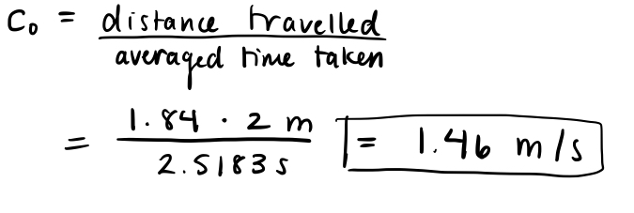

**Exercise 2 -** Deducing w0 (angular moment of a single ring of the slinky)

By direct measurement with a meter stick, we find the length of the string to be .875m so w0, the period of oscillation for a single pendulum of the suspended slinky system would be 1.51 radians per second. The calculation is:

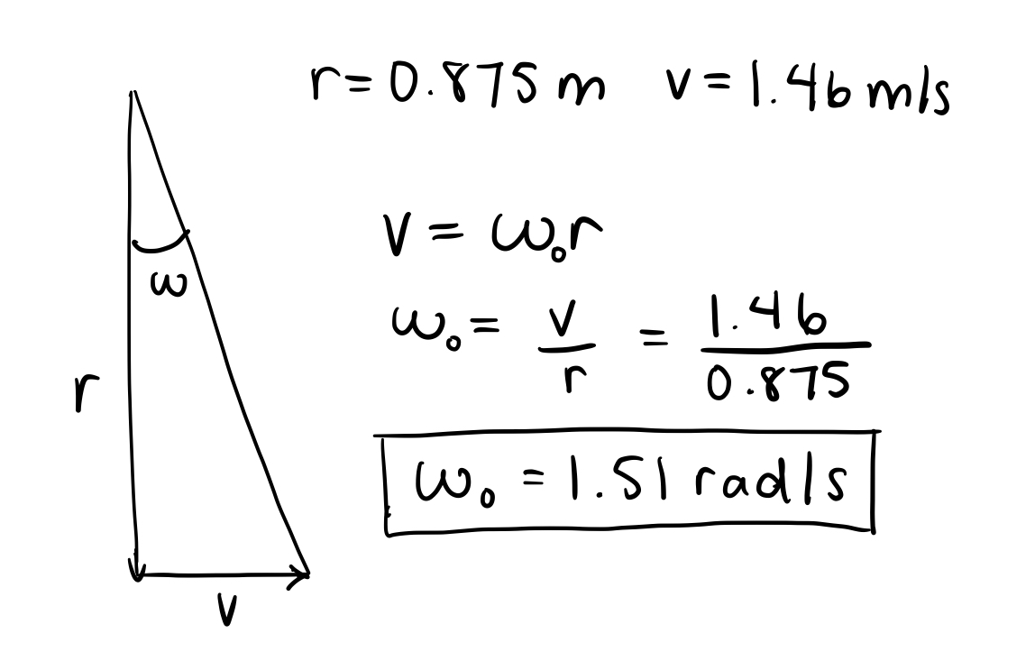

**Exercise 3 -** Plot w^2 against k^2 to deduce w0^2 and c0^2

To find the values of k for each frequency, we used this formula:

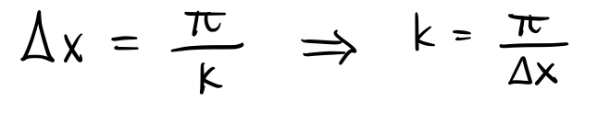

taking Δx to be the distance between the nodes (averaged if they differed slightly). The calculations came out as follows:

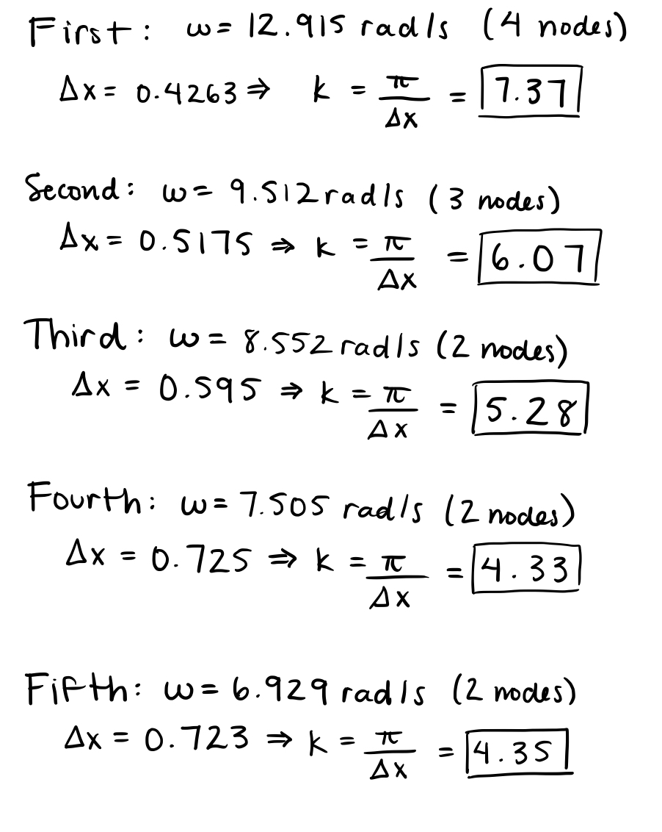

And the calculations for the errors of w^2 and k^2 were done in this way:

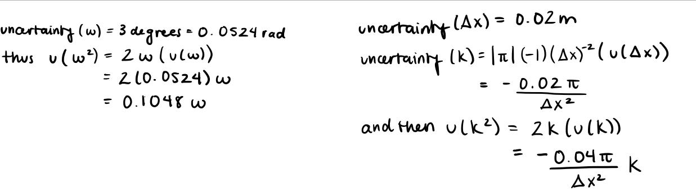

but with the uncertainty of k^2 being changed to positive, since having a negative uncertainty doesn’t make sense, though it would make no difference. We chose the uncertainty of delta x to be 2 cm, since there was a significant amount of difficulty pinpointing exactly where the nodes were, just to leave room for what was likely a significant human error.

The function for the relationship between w^2 and k^2 is:

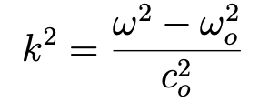

Using this function to model our data, we obtain:

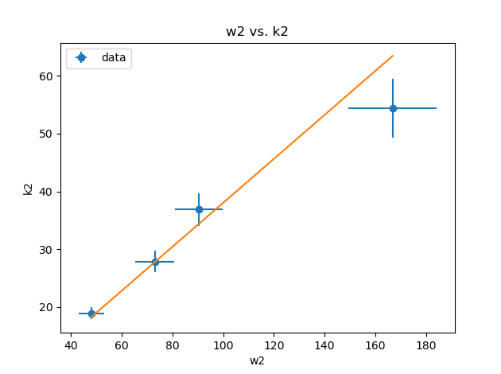

Using curve fit, we obtain:

w0 = 9.069e-05 to 4 s.f.

c0 is: 1.622 to 4 s.f.

c0 is fairly close to our theoretical value, but w0 is very different.

There is a chance that our value for w0 obtained in exercise 2 is wrong, but it likely wouldn’t be as low as the value computed in this exercise, as this new found value for w0 does not make any sense in the context of the experiments we are being asked to perform throughout this lab, or with any of the other results we found in these exercises. The value we found in exercise 2, however, did make sense within this context.

It is thus more likely due to the difficulties mentioned previously in deducing where exactly the nodes even were, since it was not a resonant frequency. There is likely a good amount of human error present leading to this poor result for w0.

**Exercise 4 -** Determine whether resonant frequencies are integral multiples of some fundamental angular frequency.

The data we found for experiment 4 is as follows:

| Number of Nodes | Position of node along the slinky (cm) | Distances between nodes (cm) | Period (degrees/sec) | Period (rad/sec) |
| --- | --- | --- | --- | --- |
| 3 | 44.5 | 47.2 | 700 | 12.217 |
|  | 91.7 | 45.8 |  |  |
|  | 137.5 | 45.8 |  |  |
| 2 | 61 | 61.7 | 475 | 8.29 |
|  | 122.7 |  |  |  |
| 1 | 91 | n/a | 340 | 5.934 |

The period does not follow a linear relationship. According to Equation 10 of the lab sheet, if resonant frequency are indeed integral multiples of some fundamental angular frequency, then the corresponding period should follow this relationship:

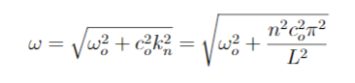

Which means:

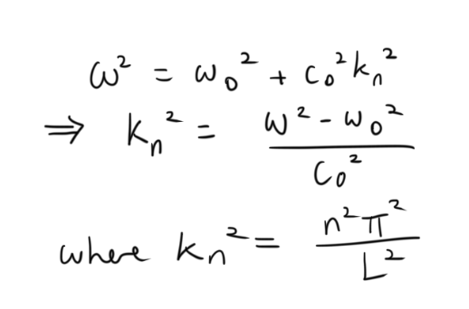

for integer n, and length of slinky L.

We can calculate the values of k using the three different experimental values of period we found, and using values of c0 and w0 from exercise 1 and 2. We can then calculate n using L = 1.840 ± 0.002 m as the length of the slinky. The length of the slinky was measured directly using a meter stick.

We get:

| Number of Nodes | w^2 (radians^2/sec^2) | Calculated k^2 | Calculated k | Theoretical n |
| --- | --- | --- | --- | --- |
| 3 | 149.26 | 68.83 | 8.30 | 2.85 |
| 2 | 68.72 | 31.12 | 5.58 | 1.92 |
| 1 | 35.21 | 15.42 | 3.93 | 1.35 |

As you can see, the calculated n values give the correct integer values corresponding to the number of nodes when rounded to 1 significant figure.

Thus, for resonant frequencies, the period omega does not increase in steps of integer multiples directly, but it is related to the value k (wave number), that increases in integer multiples. The general relation of Equation 10 is satisfied.

**Exercise 5** - Drive slinky at w < w_0 and analyze distance along the slinky versus amplitude with nonlinear fit

When driving the slinky at w < w_0, we expect the curve to be modelled by



We would like to figure out whether or not the amplitude of oscillations would be best modelled by a single exponential or by a sum of exponentials when related with the distance along the slinky.

We taped the slinky at intervals of 30cm from end to end. In the table below, d1 indicates the point of the slinky being driven, and d7 is the point of the slinky being held stationary.

The raw data is as follows:

| Points | d1 | d2 | d3 | d4 | d5 | d6 | d7 |
| --- | --- | --- | --- | --- | --- | --- | --- |
| Amplitude of Oscillation (cm)  ± 0.1 cm | 5 | 1.3 | 0.7 | 0.5 | 0.4 | 0.4 | 0 |

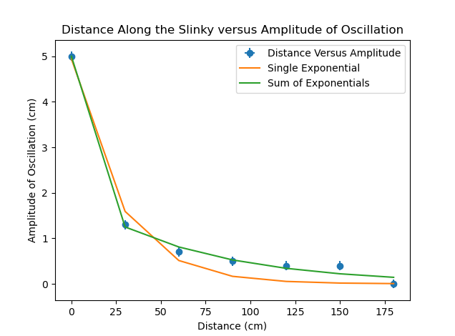

The sum of the exponentials seem to model the data better. Precisely, we can find the reduced chi-squared on both of these curves:

The reduced chi squared value of the single exponential is: 10.05 to 4 s.f.

The reduced chi squared value of the sum of exponentials is: 1.429 to 4 s.f.

We see that the sum of exponentials model give a reduced chi-squared value much closer to 1 than the single exponential model. Therefore, the sum of exponentials provide a more accurate model for our data.

Therefore, we can conclude that the amplitude of oscillation does fall off exponentially near the end of the slinky, as modeled by the equation:

y = 1.93*e**-0.0003x + 3.07*e**5x

Where y is the amplitude of oscillation, x is the distance along the slinky, where x=0 is the point of the slinky being driven.

**Exercise 6 -** Linear decay when w = w_0

For exercise 6, we drive the slinky at w ≅ w_0, at 86.5 degrees per second ± 0.3 degrees per second. Our calculated w0 is supposed to be 87 degrees/second. We use the identical setup seen in Exercise 5. Points d1 through d7 indicate points where we attached tape to the slinky to observe the slinky’s behavior. Assume the mass of the tape is negligible compared to the mass of the slinky, and therefore the impact the tape has on the motion of the slinky is also negligible. Point d1 is the end of the slinky being driven, and d7 is the end of the slinky furthest from being driven. Each taped position is separated by regular 30.0 cm ± 0.1 cm intervals.

| Points | d1 | d2 | d3 | d4 | d5 | d6 | d7 |
| --- | --- | --- | --- | --- | --- | --- | --- |
| Amplitude of Oscillation (cm)  ± 0.1 cm | 4.7 | 0.9 | 0.85 | 0.4 | 0.2 | 0.1 | 0 |

According our given lab aid sheet, the amplitude of oscillation is supposed to decay linearly at period w = w_0, as seen in equation 18:

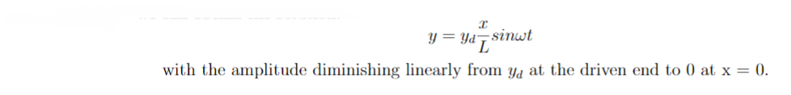

It seems that our first experimental data point, d1, however, would not fit with this relationship. If we eliminate it, we obtain:

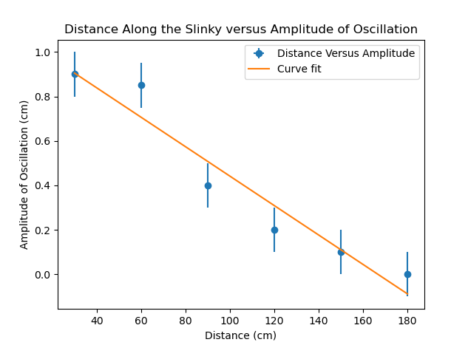

Point d1 was supposed to provide the amplitude y_d that the rest of the curve is linearly related to. We can compare it to the rest of the data set and the theoretical y_d according to curve fit:

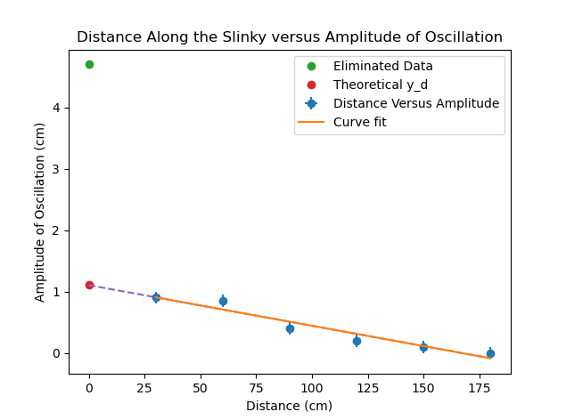

As you can see, although Point d1 is supposed to give us y_d, which the other amplitudes will be linearly related to, Point d1 does not seem to fit with the rest of the curve at all. There could be a couple reasons for this.

One reason is that perhaps the relationship used to model the amplitudes are incorrect. Perhaps we should still be using an exponential decay for this data set, like we did for Exercise 5 where w < w_0. This seems unlikely as we can calculate the reduced chi-squared value of the curve with our data. We obtain a reduced chi-squared value of 1.301 to 4 s.f., which is only larger than 1 by 0.301, suggesting the linear curve is an accurate fit for the rest of the data points.

Also, if we attempt to do a nonlinear curve fit using model function: y = ce^kx for some constants c and k on this data with the eliminated data point, with initial guess being c = 4 and k = -1:

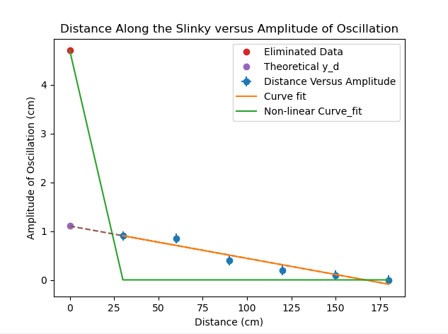

It seems curvefit is unable to find the optimal parameters for fitting this curve as an exponential.

Because of the accurate linear curve, and curve fit’s strange behavior when we attempt to model the experimental data as an exponential, this seems to indicate that either perhaps some errors occurred when taking data for Point d1, or it may suggest the relationship does not work when the slinky is too close to the driving motion. Therefore, we should eliminate Point d1 in our data analysis.

We can conclude that when w = w_0, distance along the slinky and amplitude of oscillation are proportional by a factor of -0.0066.

**Exercise 7**

This exercise just instructed about the effect of lowering the filtering combs and how it shortens the string length. There are no real observations to make here apart from remarking that it is indeed true that the string length is lowered, and thus that the angular frequency will be larger (as can be seen by the fact that angular frequency is inversely proportional to radius, which in this case is the string length).

**Exercise 8**

In this exercise, we saw what was described in the lab manual happening to the slinky (we’ll attach a video of what happened to our submission). The section in which the string was not shortened, section 1, had a resonant pattern to it, with the end at which it met with the filtering comb in section 2 swinging dramatically, like the nodes in exercise 4. Aside from the beginning of section 2, where it met with section 1, there was not much movement of the spring. Like the manual suggested, it was as if the fixed end had been moved up 2 sections’ lengths towards the driven end.

**Exercise 9**

For this exercise, the motor speed was adjusted so that the slinky was moving with a resonant frequency when combs 2 and 3 were lowered. Then, with the motor turned off, the third comb was lifted and the first comb was lowered. When the motor was turned on again, there was no observed tunneling of the energy from the driving motor. The motion of section 3 was not very large or resonant looking compared to the motion of section 1 in exercise 8. However, in observing the video we took, it does appear that the third section was slightly more mobile than the first or second section. But not in any significant way to suggest a tunneling effect as suggested in the lab manual.

**Exercise 10 -** Determine beat period of tunneling

The beat period of tunneling appears to be 1.5 seconds, as it oscillates 6 times in 4 seconds as seen in the video recording.

**Exercise 11** - Compare resonant frequency with beat period of tunneling

The beat frequency of tunneling was calculated like this:

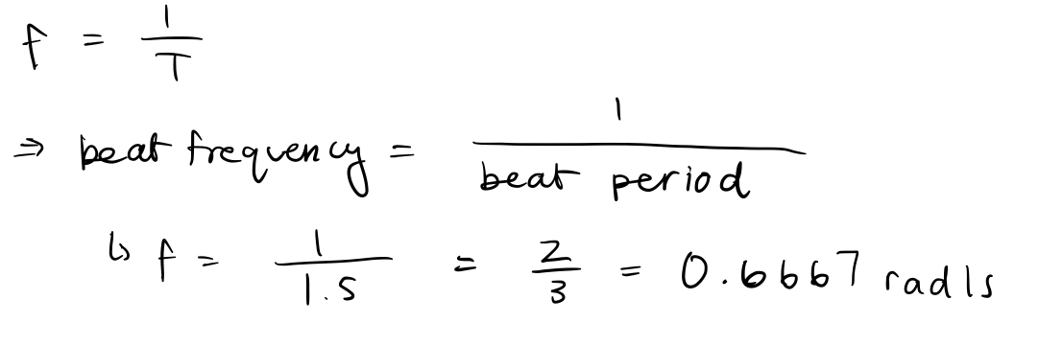

And given that we were only able to discover one resonant frequency for this exercise (most likely due to limitations in the motor speed, as it was unable to go fast enough to attain the next resonant frequency from what we could find), we will just compare it to that value. The frequency that we found resonance in for this exercise was the symmetric frequency (unable to find the antisymmetric one), and it was found to be 9.599rad/s. This is quite a different value from the beat frequency of tunneling, which was found to be 0.6667 rad/s. The fact that frequency was lowered seems to suggest that a lot of energy was dissipated through the lowering of the combs.

**Conclusion**

In conclusion, this was quite the tricky lab to perform. The exercises themselves were simple to conduct, but obtaining accurate results proved to be very challenging, as it wasn’t possible to get very precise measurements, and a lot of the errors in exercises were likely due to human errors in trying to take these measurements with our own judgement. However, this lab was also pretty fascinating. We were able to witness phenomena like the resonant frequencies of the slinky, and how the motion of the slinky differed with the lowering of the filtering combs and thus the shortening of the strings of certain sections of the slinky. Also, we could see the oscillations’ tunneling behavior when combs were lowered and raised. We were also able to observe the effect that different frequencies with different relations to w0 had on the movement of the slinky.